
THE STEALTH LOW NOISE DRILL
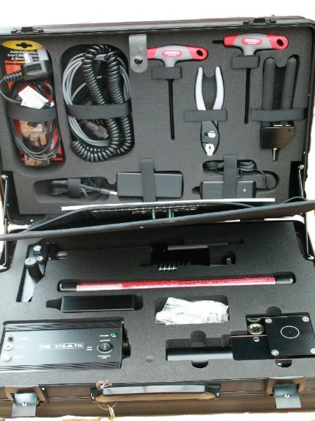
The new STEALTH Low Noise Drilling system, often referred to as ‘Silent Drill’, is a small unique drill assembly which has replaced previous low noise drill units which are no longer in production. It has several major new features for 2015, including a new integral rechargeable battery pack, control panel and remote hand controller coupled to corrugated cable up to 10 feet from the wall being attacked. A more powerful motor and gearbox which combine to produce a high torque to the drill head.
THE STEALTH Low Noise Drill has been designed to enable specialist operators to covertly gain access by drilling through a wall to a target room, or building in order to obtain vital audio or visual intelligence before a Rapid Intervention is made. This latest system does not use water to cool the drill bit, which in the past could compromise an operation by leaking water into a target location, or clogging the drilling equipment.
THE STEALTH is provided with a through wall handheld obstruction detector, which is used to locate any obstacles that could be encountered by the drill and endanger the operation or the safety of the operators.
It can detect wall studs, metal or any fittings such as electricity, water or gas pipes or cables, and is an essential aid for the Health & Safety of all operatives prior to the commencement of covert drilling operations.
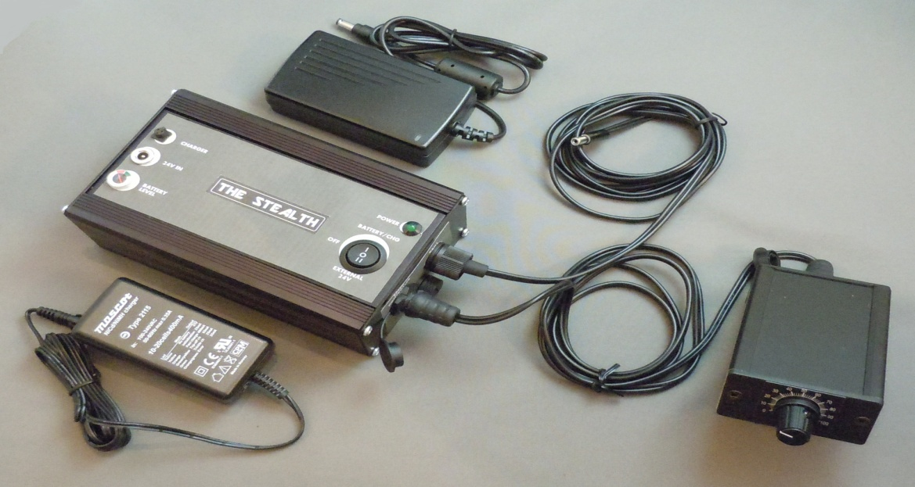

“THE STEALTH LOW NOISE DRILL - THE WHOLE SOLUTION IN ONE CASE”
TECHNICAL SPECIFICATION
INTERNAL BATTERY PACK: 24VDC NMH (3300 mAh)
INPUTS: 24VDC Input socket from ANY 24 Volt source
Charger Input Socket
Remote Controller socket
OUTPUTS: Drill Output Socket
Drill Output Lead of 2 metres in length
CONTROL PANEL: Power Source Selector Switch
24V IN
OFF/CHG BATTERY
POWER ON - LED INDICATOR LIGHT
DIMENSIONS: 165mm x 105mm x 61mm
WEIGHT: 1.5Kgs
REMOTE SPEED CONTROL: Control Knob 0-100% (Drill Speed 70rpm@100%)
SUPPLY VOLTAGE: 24VDC from Main Control Unit
MOTOR CURRENT: Continuous –MAX 3A
MOTOR CURRENT MAX: 6A (10s)
SHORT CIRCUIT CURRENT: 30A
PVM MOTOR FREQ: 25KHz
DIMENSIONS: 60mm x 65mm x 36.5mm
WEIGHT: 250 g
SUPPLIED WITH THE KIT IS A COMPREHENSIVE AND EASY TO FOLLOW DRILL GUIDE IN RELATION TO THE BUILDING INFRASTRUCTURE AND FABRIC THAT COULD BE ENCOUNTERED AND THE RIGHT DRILL BIT FOR USE AS BEST PRACTISE TO ACHIEVE THE AIM COVERTLY
